**EMERGING METHODS FOR EARLY DETECTION OF FOREST FIRE**

# IMAGE PRE-PROCESSING

**APPLYING IMAGEDATAGENERATOR TO TRAIN AND TEST DATASET**

|  |  |
| --- | --- |
| Team ID | PNT2022TMID17141 |
| Project Name | Project- Emerging Methods For Early Detection of Forest Fire |

The ImageDataGenerator class has three methods, 1.flow ( ),

1. flow_from_directory ( )
2. flow_from_dataframe ( ) to read the images from a big numpy array and folders containing images.

flow_from_directory ( ) expects at least one directory under the given directory path.

# APPLYING ImageDataGenerator to train dataset:

ply**flow_from_directory ( )**methodfor Train folder.

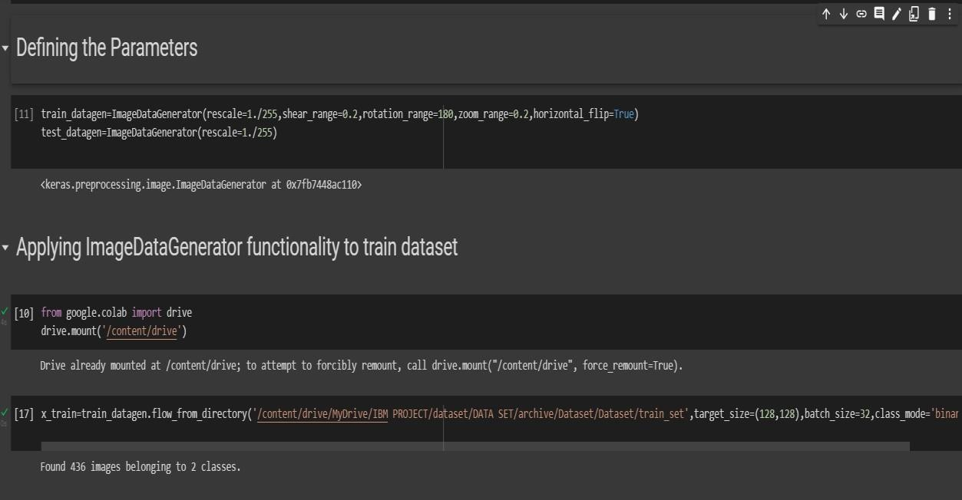

# APPLYING ImageDataGenerator to test dataset:

Applying the **flow_from_directory ( )** methodfortest folder.

